Important points that I noted in the AWS Elastic beanstalk

- An application is a logical collection of Elastic Beanstalk components, including environments, versions, and environment configurations. An application can have multiple versions.
- An environment is a collection of AWS resources running an application version.
- A platform is a combination of an operating system, programming language runtime, web server, application server, and Elastic Beanstalk components.
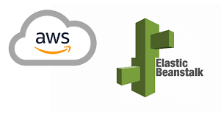 The AWS Elastic Beanstalk plugin is a Cloud Deployment plugin. It is run during the development and deployment process to manage and deploy web applications into AWS Elastic Beanstalk.

